eTool Final Report

Travis Sondgerath

12/20/2020

Table of Contents

Overview 3

Data Collection 3

Summary: 3

Outstanding Considerations: 3

eTool User Guide 4

Summary: 4

Outstanding Considerations: 5

eTool Development 6

Summary: 6

Outstanding Considerations: 6

Adding Users to the eTool 7

Summary: 7

Outstanding Considerations: 7

Credentials 7

# Overview

|  |  |  |
| --- | --- | --- |
| Objective | Deliverable | Result |
| 1. Support the development of Ona surveys to be used to in the field to collect data on newly deployed equipment, as well as to update data on existing equipment already in circulation | Data collected in the field will be visible in the eTool | Survey forms reviewed and available on Ona. |
| Document instructions for collecting data using the Ona forms using ODK Collect | Instructions given to laboratory staff and used to collect equipment information. |
| 1. Support the deployment of an ASLM administered reporting platform | The eTool will be available to users through an internet browser | The eTool is hosted on Digital Ocean, a could infrastructure provider. |
| Users will be authenticated before viewing the eTool | Users prompted for credentials at the eTool home screen. |
| Reports and instructions will be provided in the form of pdf documents where appropriate | Present document outlines administrative considerations and processes. |
| 1. Develop a final report describing activities | Create necessary documentation to describe activities | Present document |

# Data Collection

## Summary:

To support data collection on mobile platforms as well as PC even where internet connection is not possible, we have created data collection forms using Ona, an open source survey platform. Surveys can be referenced using the mobile application, ODK Collect. Response data is stored on Ona and referenced in the eTool code. Currently developed survey links are referenced below.

[New Equipment Registration](https://ona.io/pacafenet/99874/460026/webform)

[Equipment Activity Form](https://ona.io/pacafenet/99874/460087/webform)

[Request Calibration](https://ona.io/pacafenet/99874/461478/webform)

[Request Maintenance](https://ona.io/pacafenet/99874/461477/webform)

## Outstanding Considerations:

Thus far, the only data collected by laboratory personnel is the New Equipment Registration form given our limited interaction with laboratory staff. The registration form was meant to capture the state of either new equipment in the lab or equipment already present in the lab that was not captured in eTool data. The other forms were meant to capture information on maintenance activities as well as give laboratory staff the ability to request either calibration or maintenance.

# eTool User Guide

## Summary:

The eTool is currently being hosted at <http://104.248.226.50/eTool> using a Linux image hosted on Digital Ocean. Users will be prompted for credentials at the link above. Users must be added by system administrators and developers. Report viewers can be added by users with ‘sudo’ access using the following commands below.

cd /etc/nginx

sudo htpasswd /etc/nginx/.htpasswd exampleuser

Below is a description of the eTool itself. The report below documents key descriptive information about the current state of the equipment data. Charts are provided to describe the number and percentage of pieces of equipment requiring either calibration or maintenance.

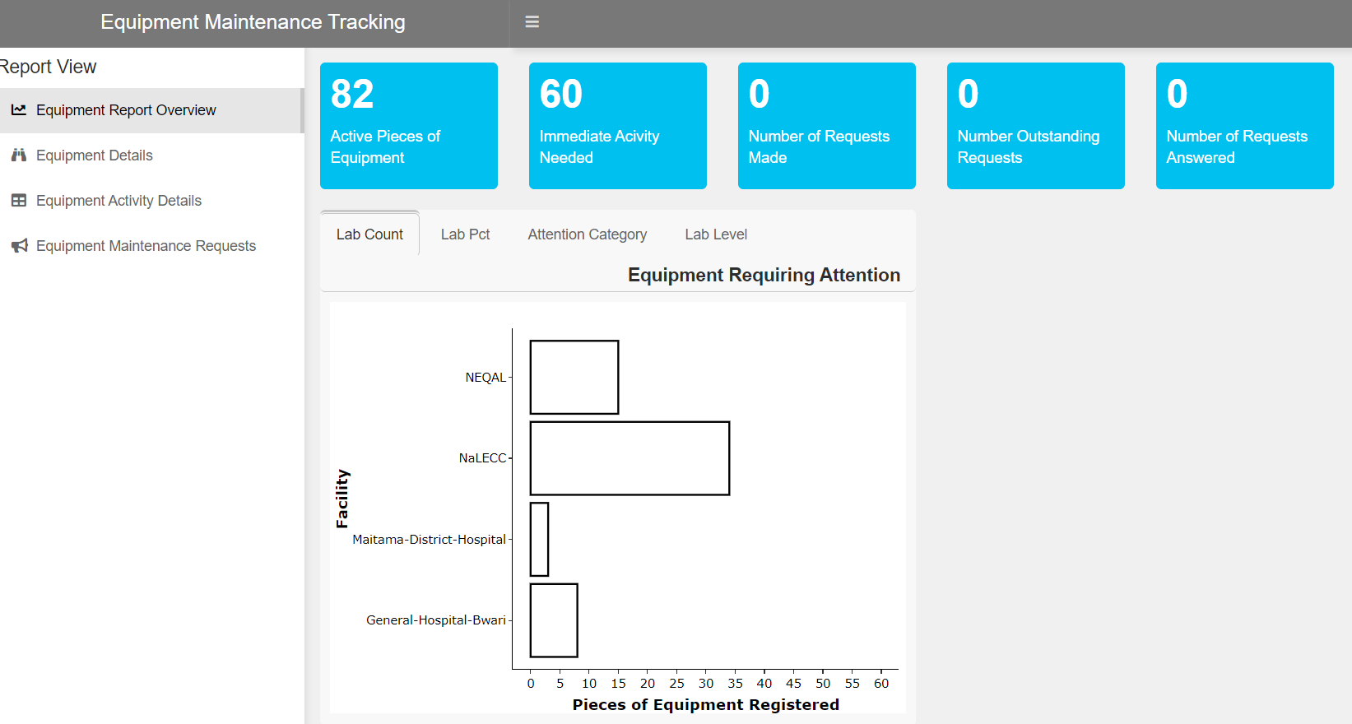

This report shows information about the current state of equipment documented in the eTool. Information about each piece of equipment is shown including maintenance status, location, and type of equipment described. Equipment ID’s are highlighted in red if responses indicate the need for equipment calibration or maintenance soon. Data can be filtered using the selectors at the top of the report.

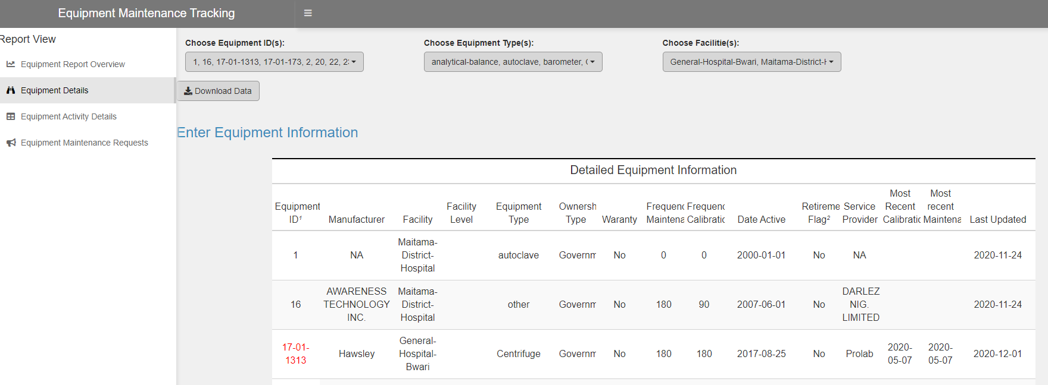

This report describes focuses on equipment characteristics including warranty status and service providers. Additionally, expected calibration dates are included.

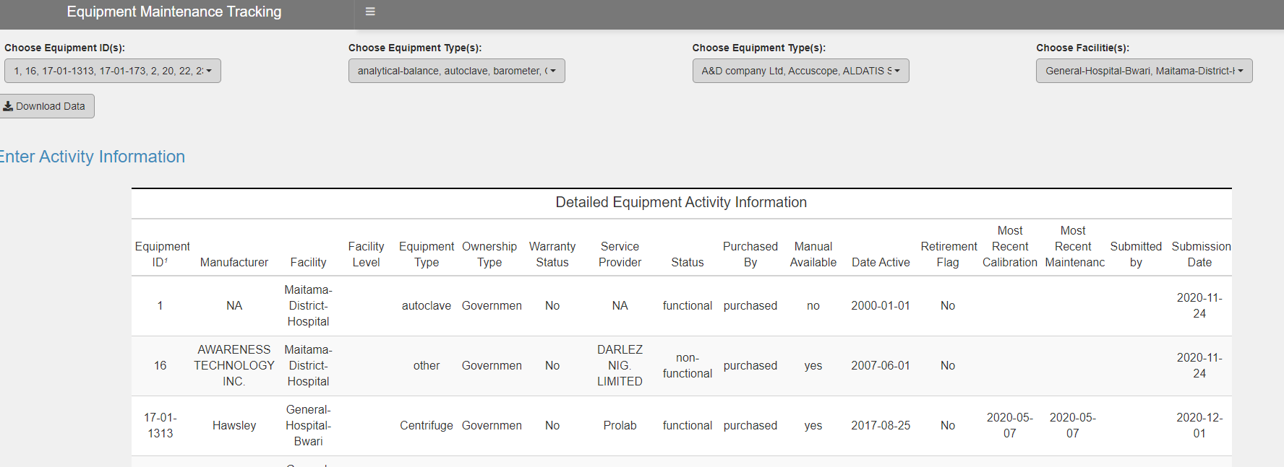

This report shows service dates for equipment. However, data has not been collected for requests yet.

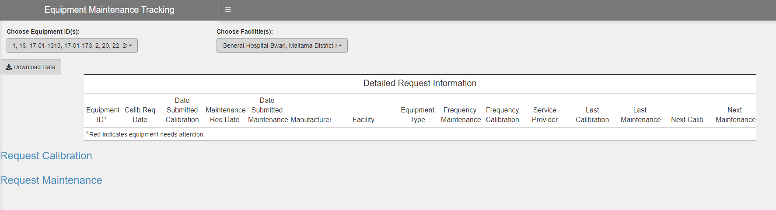

## Outstanding Considerations:

Additional work needs to be done for the laboratory staff to use the other forms in order to documents equipment service.

# eTool Development

## Summary:

All relevant documents and development work are saved at GitHub in a project account linked below. The three most important repositories are highlighted below. The shiny-server repository is linked to the Digital Ocean image which is a Linux instance. A user with sudo access must run the commands below to make the current eTool application code available on the internet. The project GitHub password will likely need to entered after running the commands below.

cd /srv/shiny-server

sudo git pull

[Repository Location](https://github.com/paceafenet)

etool_dev contains all development code, proof of concepts, and ad-hoc reports created during this project.

Lastly, the Documentation repository contains all binary files related to project planning and survey development during this project.

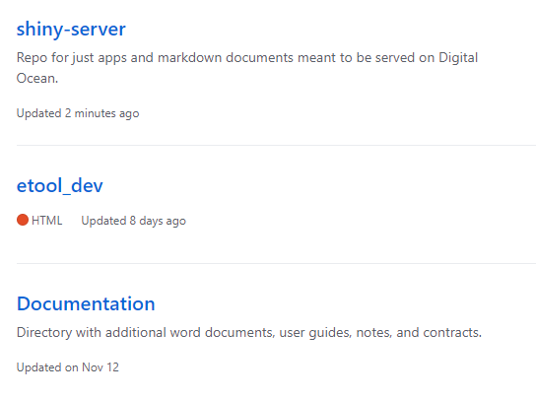

## Outstanding Considerations:

Updates referenced above will need to be done by someone with at least some technical knowledge.

# Adding Users to the eTool

## Summary:

A user with sudo privileges will need to run the commands below.

cd /etc/nginx

sudo htpasswd /etc/nginx/.htpasswd exampleuser

## Outstanding Considerations:

This process is unlikely to scale well with a large user base. Additionally, an admin user with sudo privileges will have to create users and unless the user is present, also create their password. General users cannot change their password with the above commands without sudo privileges which would be unwise to distribute to a large group of users. A better authentication scheme would need to be implemented for larger scale use. The current approach is excellent for proof of concept projects such as this one.

## Credentials

Credentials and handoff instructions will be coordinated once the contractor payment process is initiated.